**Scientific Poetics and Neo-Latin: A Roundtable**

Friday, 30 May 2025, 2-5:30pm

Faculty of English (University of Cambridge), SR/24

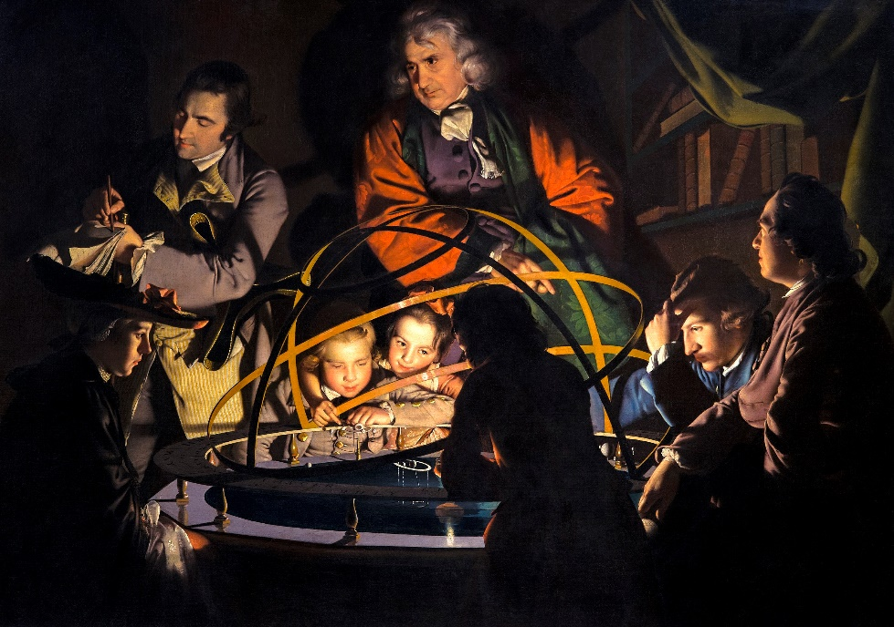

This roundtable is a collaboration between the Cambridge Neo-Latin Seminar and the AHRC/DFG project *Scientific Poetry and Poetics in Britain and Germany from the Renaissance to the Enlightenment*, dedicated to the relationship between Neo-Latin and vernacular scientific poetry. It asks what early modern writers thought poetry could express above and beyond what prose could do and how this question is inflected by their choice of language. We will explore whether poetry’s varied resources of genre – epic, didactic, pastoral, epistle, satire, elegy, lyric, epigram – could say things unavailable to prose. The kind of detail and difficulty of such poetry will be considered, and if there is a distinctive poetics generated out of difficulty. We will probe writers’ reasons for choosing Neo-Latin or the vernacular, and the implications for their negotiation of poetic style. Is the literary yield of scientific poetry different in Neo-Latin from the vernaculars? How are the terms ‘scientific’ and ‘poetics’ to be brought together in relation to Latinity during the period under investigation?

Short papers, on topics ranging from the transit of Venus and the life of fish to the physiology of inspiration and the Stinkhorn mushroom, will stimulate roundtable discussion involving all present.

*Papers:*

Dominik Berrens (Mainz), Zhiyu Chen (Cambridge), Tania Demetriou (Cambridge), Kevin Killeen (York), Johanna Luggin (Innsbruck), Emma Perkins (Cambridge), Caroline Spearing (Exeter), Liba Taub (Cambridge), Irina Tautschnig (York)

*Discussants:*

Kate Allan (Anglia Ruskin), Jacob Currie (Cambridge), Cassie Gorman (Anglia Ruskin), Philip Hardie (Cambridge), Anna-Maria Hartmann (Cambridge), Sophie Read (Cambridge), Andrew Taylor (Cambridge)

This will be a hybrid event. To register, please email: [td227@cam.ac.uk](mailto:td227@cam.ac.uk) or [irina.tautschnig@york.ac.uk](mailto:irina.tautschnig@york.ac.uk) by 25th May 2025.